

IPL DATA ANALYSIS

Report

Course Name & Code: Data Visualization (INTB233)

Submitted By:

Name : Saivinesh Gundaboina

Reg.No: 12112032

Roll.No: 25

Section: K21BG

Submitted To :

Aashima Madam

Declaration:

I, G.Saivinesh 12112032, solemnly declare that the IPL Data Analysis Report presented herein is the result of my own work and research. All analyses, findings, and conclusions contained within this report are based on authentic data and have been conducted in accordance with ethical research practices.

I further declare that all external sources referenced in this report have been duly acknowledged and credited. Any quotations, data, or ideas derived from these sources have been appropriately cited in accordance with the prescribed referencing style.

I take full responsibility for the accuracy and integrity of the information presented in this report. Any errors or omissions are entirely unintentional and do not detract from the overall validity of the analysis.

I understand the importance of academic honesty and integrity, and I affirm that this report has not been submitted, in whole or in part, for any academic or professional purpose elsewhere.

Date: 20 April 2024

Signature: G.saivinesh

Acknowledgement:

I would like to express my sincere gratitude to IPL Data Analysis for providing the dataset used in this analysis. Without their contribution, this research would not have been possible.

I also extend my appreciation to the Tableau software and Kaggle datasets for given great data of datasets and graphs by I this did the Dashboard in very reasonable way and almost I

covered all data analysis about Indian Premier League (IPL).

Signature: G.saivinesh

Tables Of Contents:

1. Introduction
2. Objectives or Scope of the Analysis
3. Source of Dataset
4. Analysis on dataset
5. Introduction
6. General Description
7. Specific Requirements, Functions and Formulas
8. Analysis Results
9. Visualizations
10. List of Analysis with results
11. References
12. Bibliography

Introduction:

**Tableau** is a powerful tool used for data analysis and visualization. It allows the creation of amazing and interactive visualization and that too without coding. Tableau is very famous as it can take in data and produce the required Data Visualisation output in a very short time. Basically, it can elevate your data into insights that can be used to drive your action in the future.

The **Indian Premier League (IPL)**, also known as the **TATA IPL** for sponsorship reasons, is a men's Twenty (T20) Cricket league held annually in India. Founded by the BCCI in 2007, the league features ten city-based franchise teams.The IPL usually takes place during the summer, between March and May each year. It has an exclusive window in the ICC Future Tours Programme, resulting in fewer international cricket tours occurring during the IPL seasons.

The IPL is the most popular cricket league in the world; in 2014, it ranked sixth in average attendance among all sports leagues. In 2010, the IPL became the first sporting event to be broadcast live on Youtube. Inspired by the success of the IPL, other Indian sports leagues have been established. In 2022, the league's brand value was estimated at ₹90,038 crore (US$11 billion). According to the BCCI, the 2015 IPL season contributed ₹1,150 crore (US$140 million) to India's GDP. In December 2022, the IPL achieved a valuation of US$10.9 billion, becoming a decacorn and registering a 75% growth in dollar terms since 2020 when it was valued at $6.2 billion, according to a report by the consulting firm *D and P Advisory*. Its 2020 Final became the most streamed live event on the internet, with 32 million viewers.

Objectives or Scope of the Analysis:

1. To know about who won the title as per season.
2. To know about who is the orange cap holder as per season.
3. To know about who is the purple cap holder as per season.
4. To know about how many sixes scored by batters as per season.
5. To know about how many fours scored by batters as per season.

Source of dataset:

Obtaining datasets related to the Indian Premier League (IPL) can sometimes be tricky due to copyright restrictions and commercial interests. Obtaining datasets related to the Indian Premier League (IPL) can sometimes be tricky due to copyright restrictions and commercial interests.

Kaggle is a popular platform for finding datasets related to various topics, including sports. You can search for "IPL" or "Indian Premier League" on Kaggle to find datasets related to matches, players, team performances, etc.

Analysis on Datasets :

Introduction:

The Indian Premier League (IPL) is a professional Twenty20 cricket league in India, founded by the Board of Control for Cricket in India (BCCI) in 2007. It has since become one of the most popular and lucrative cricket leagues globally, attracting top cricketing talent from around the world.

General Description:

The Indian Premier League (IPL) is a domestic, annual Twenty20 cricket tournament in India, organized by the IPL Governing Council, under the aegis of the Board of Control for Cricket in India (BCCI). It is the most watched Twenty20 tournament and the second-best-paying sporting league globally.

Specific Requirements:

1. Datasets
2. Images
3. Details of Runs by batter scored
4. Details of Wickets Taken by bowlers
5. Details of Title Winners

Functions:

1. Using filter functions to show all seasons

Formulas:

AGG(avg(0))

AGG(AVG(0))

Analysis Results:

Screenshots:

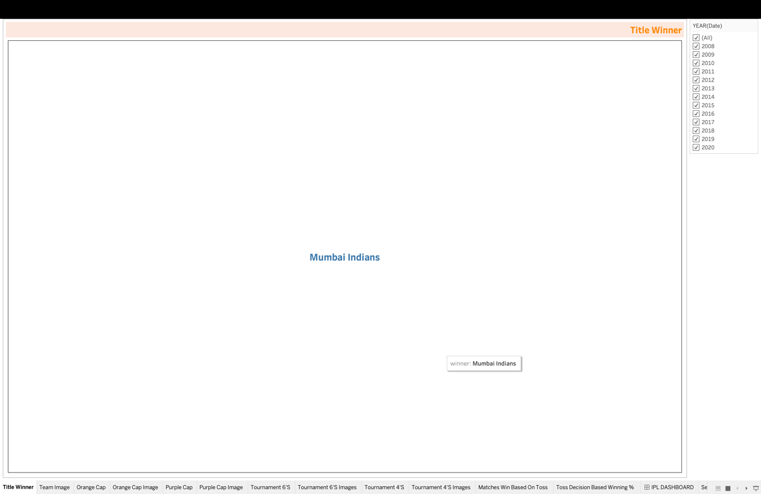

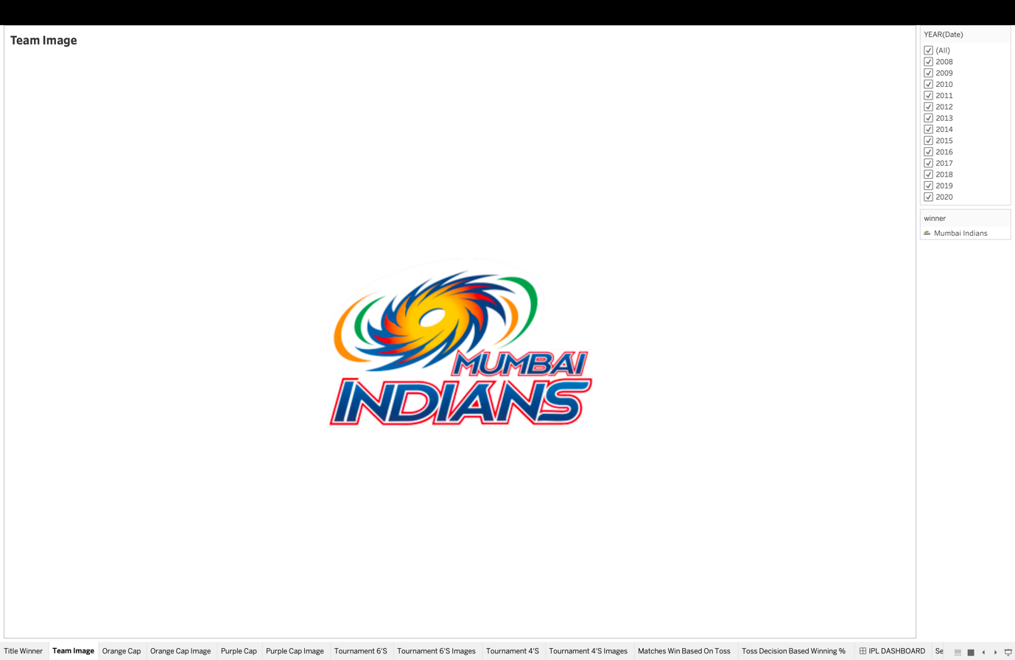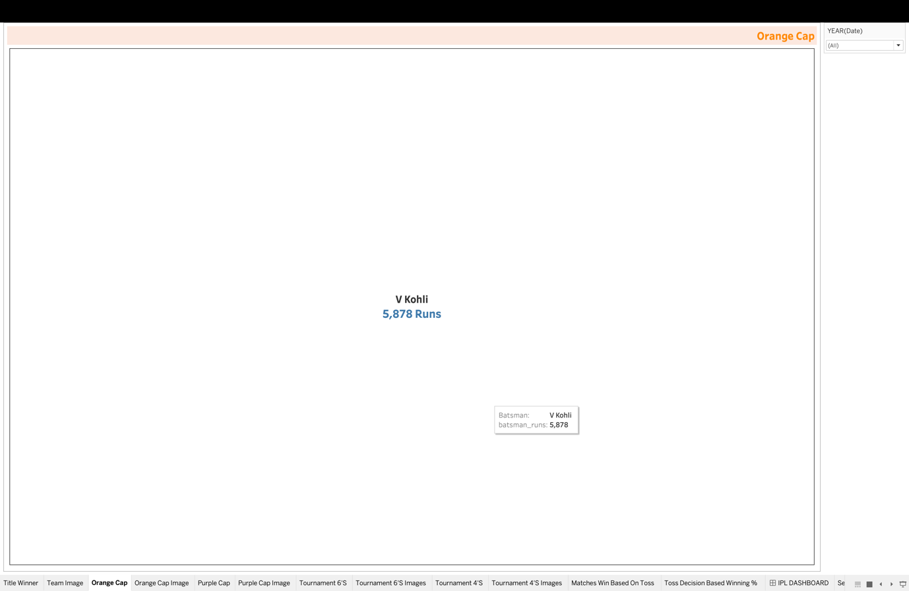

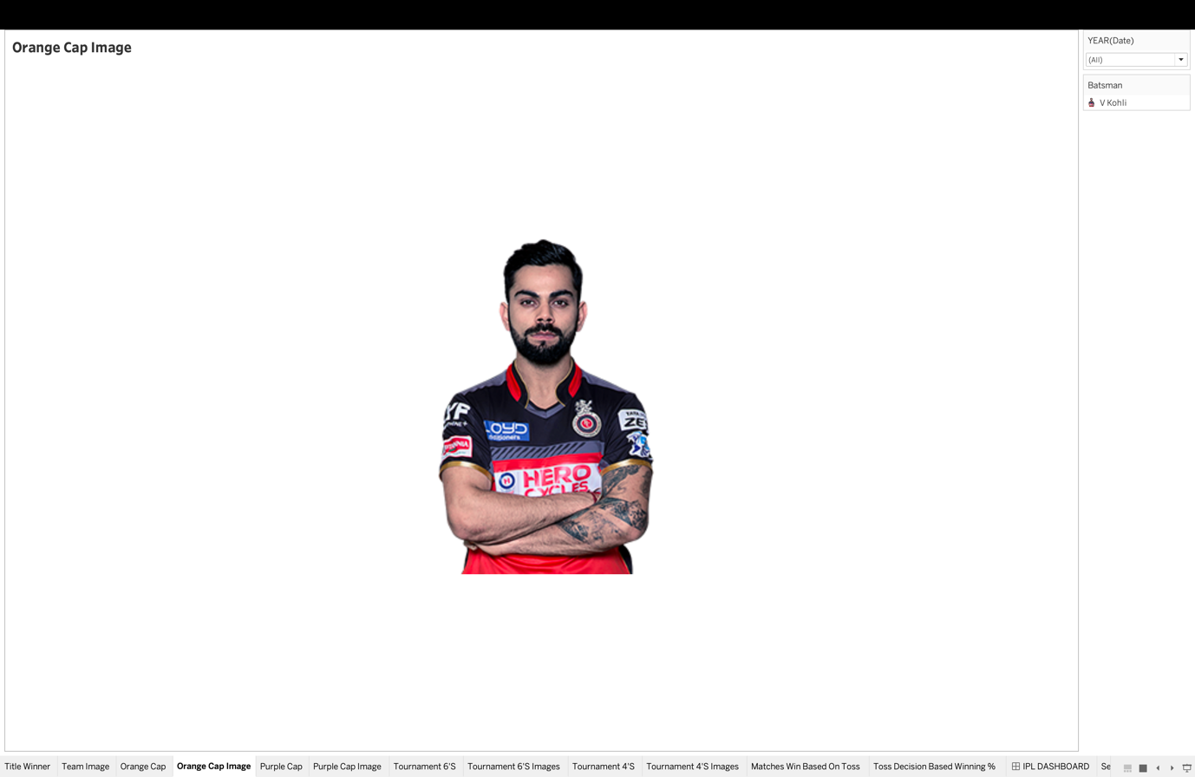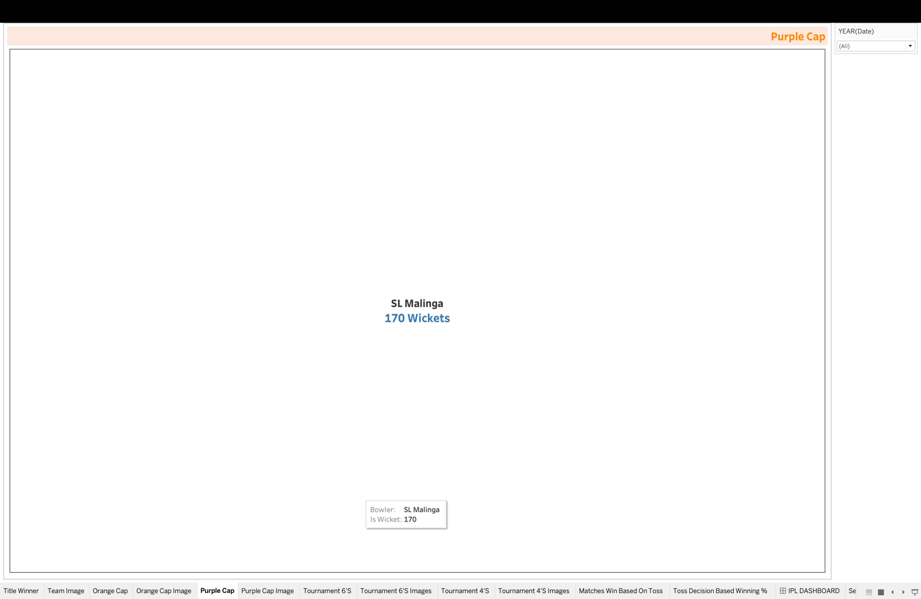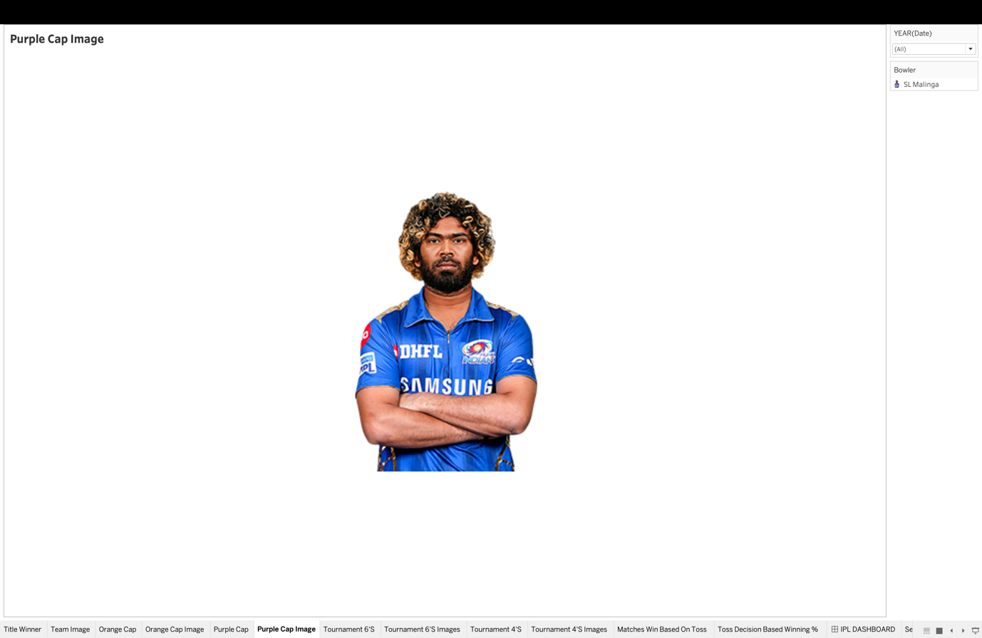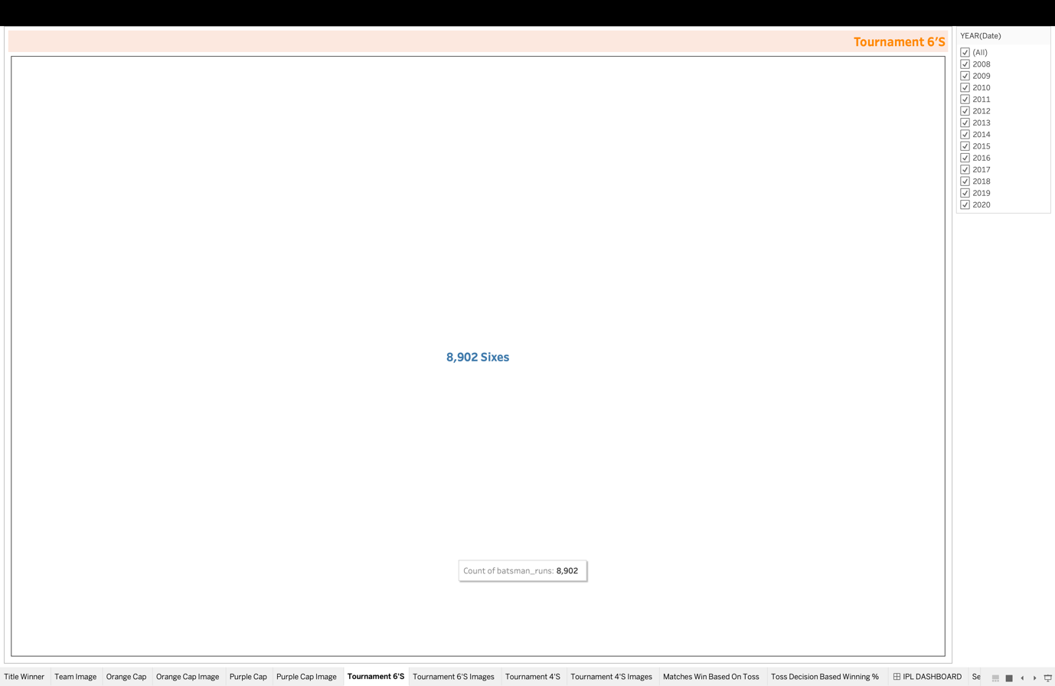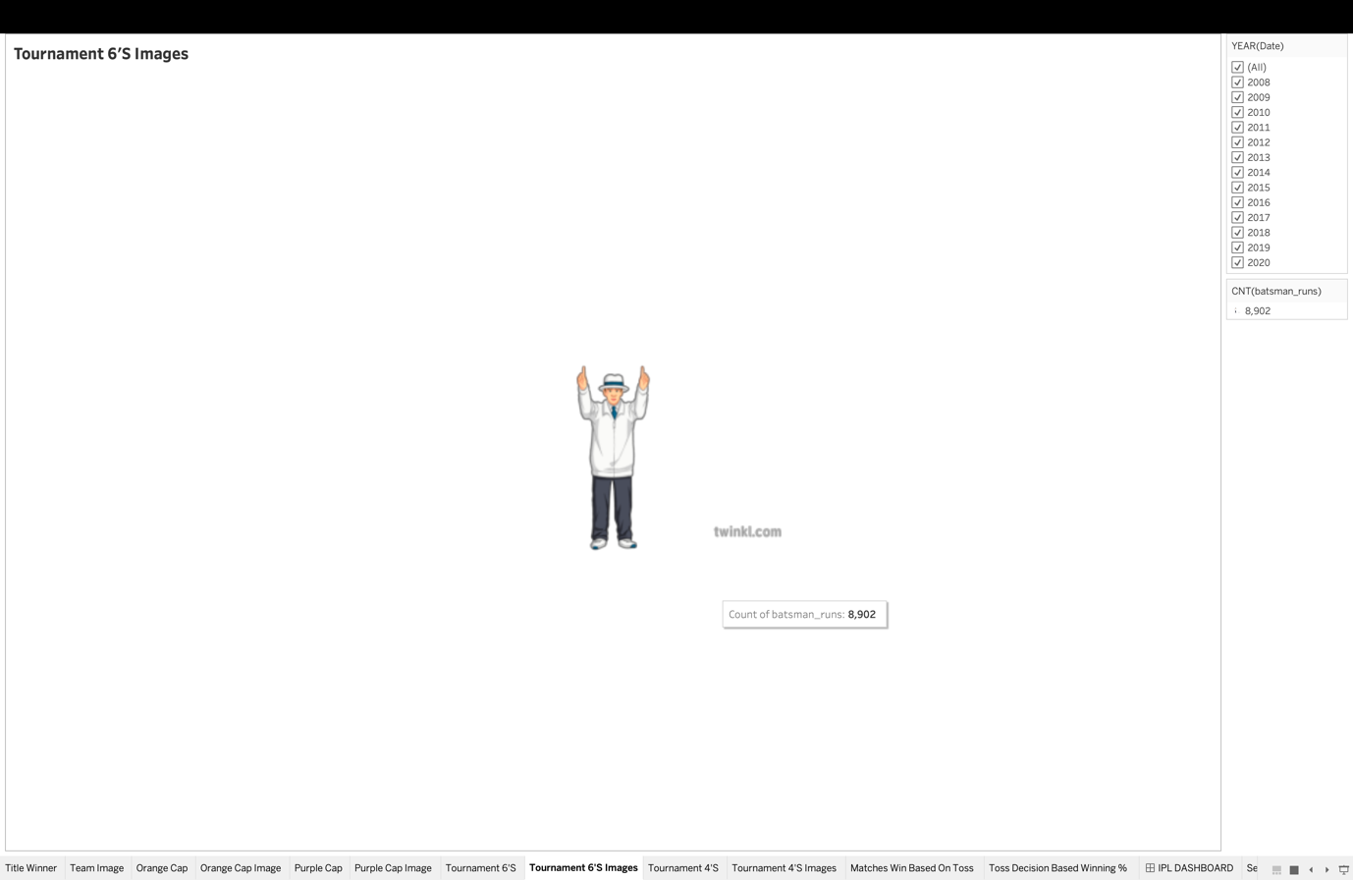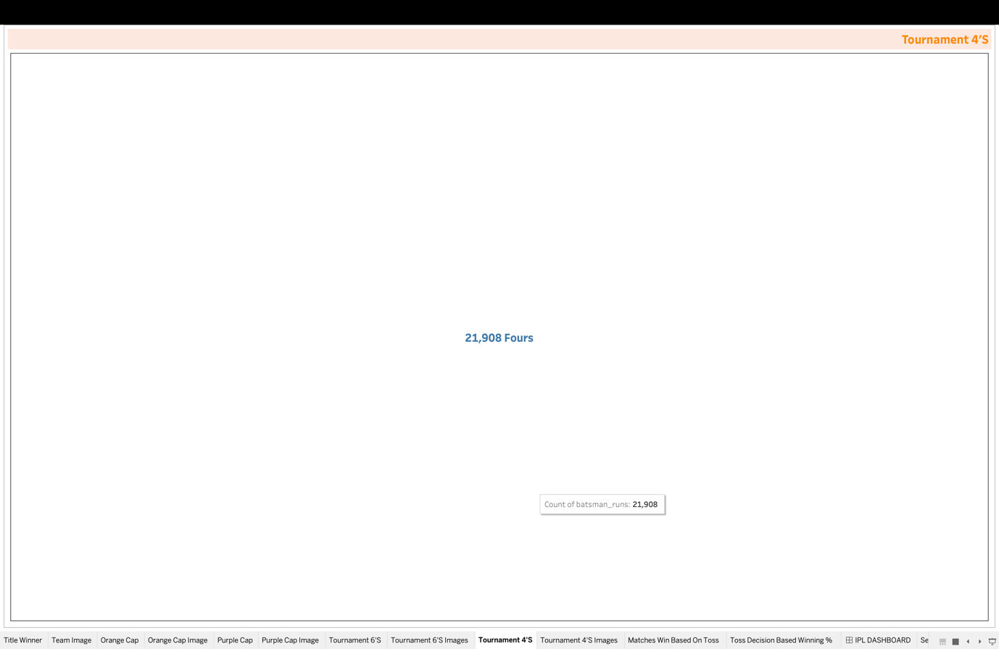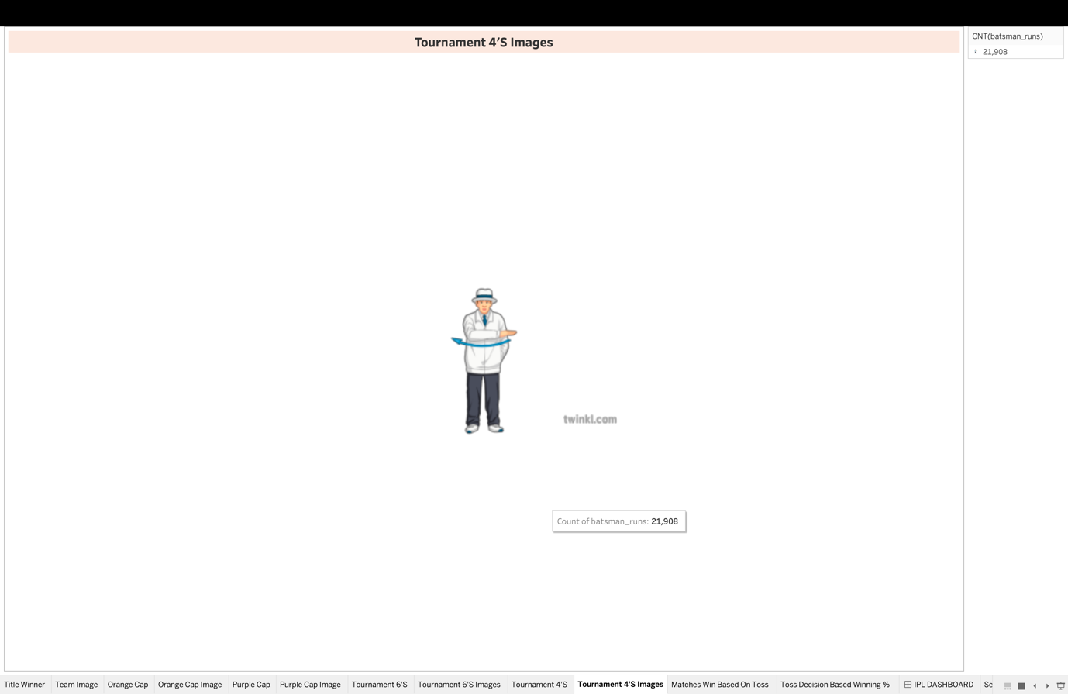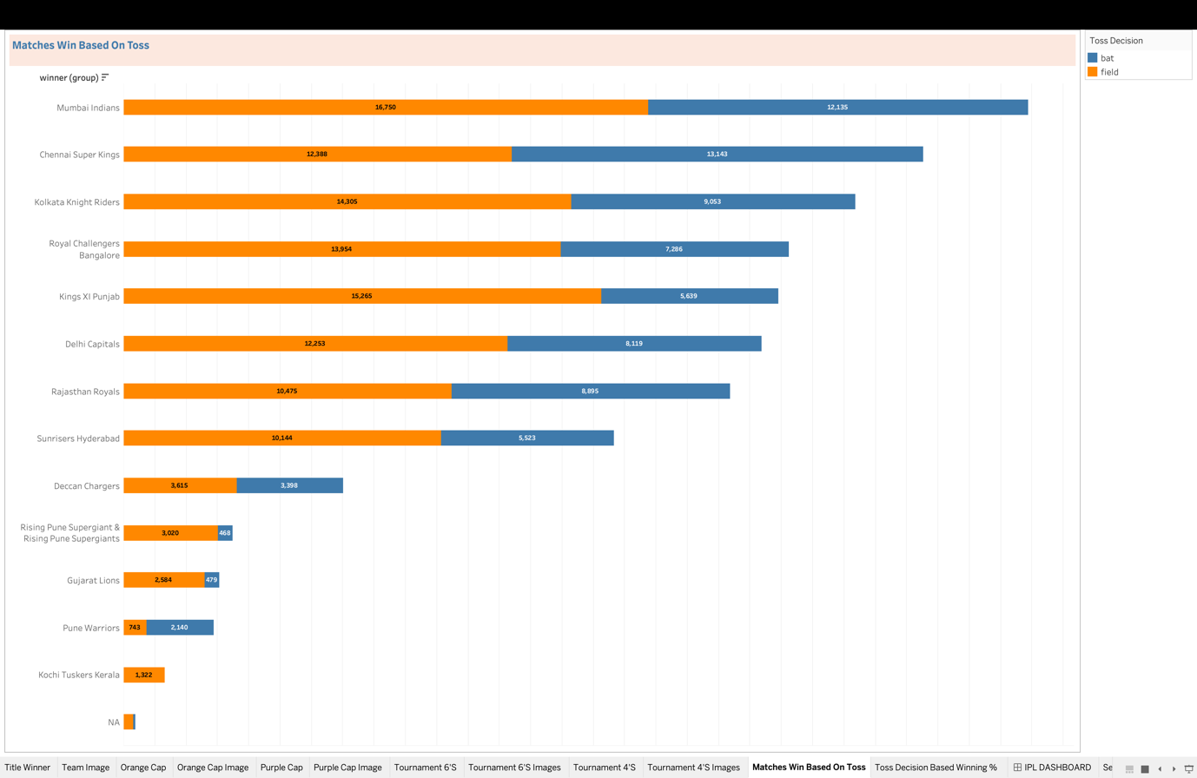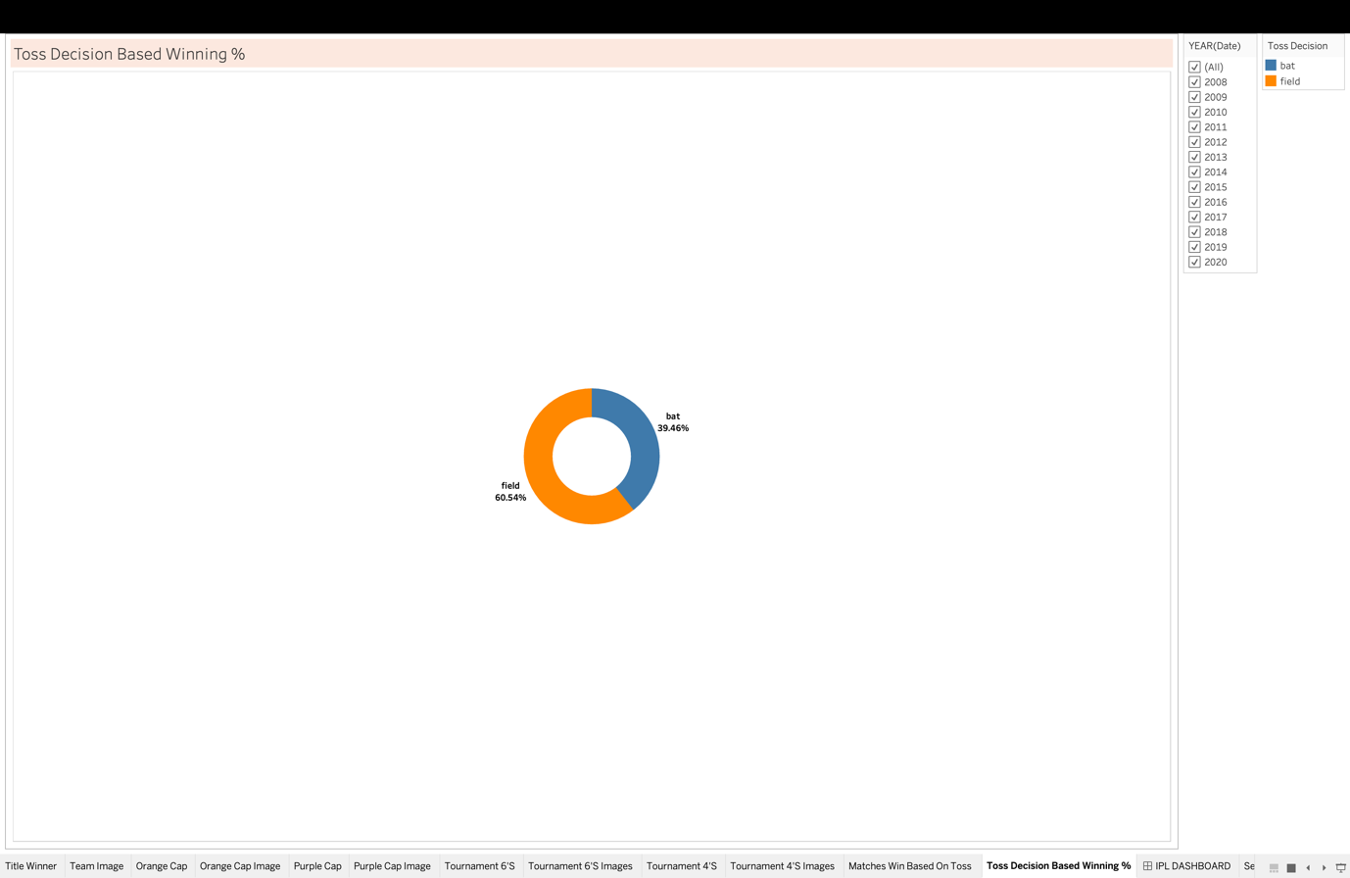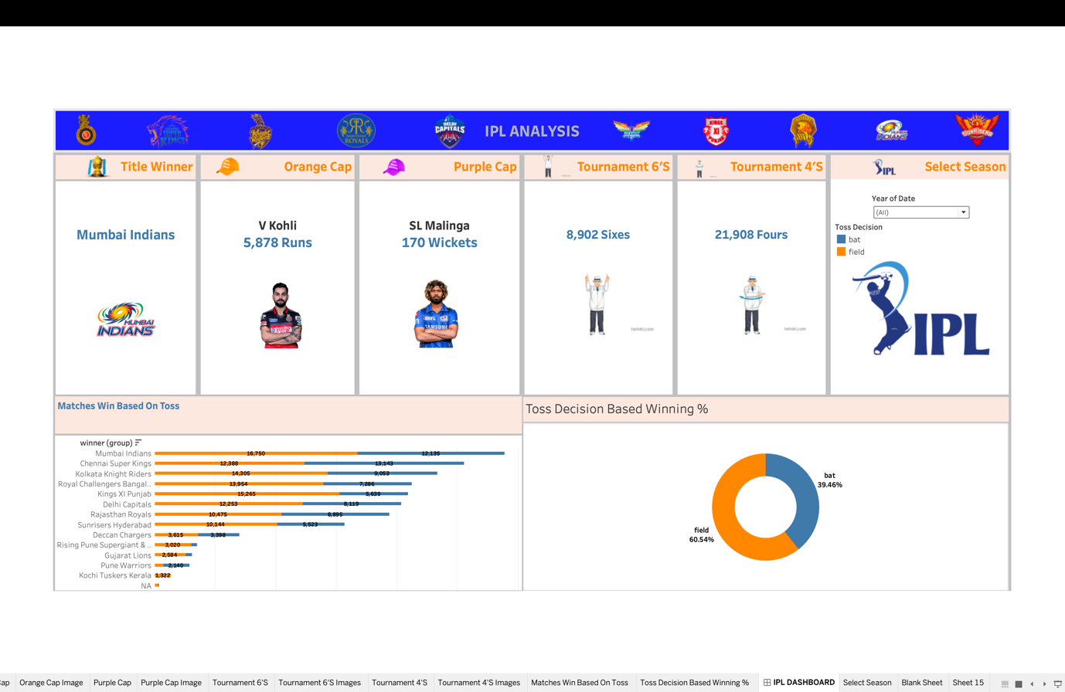

References:

<https://www.kaggle.com/datasets/patrickb1912/ipl-complete-dataset-20082020>

Bibliography or Conclusion:

In conclusion, IPL data analysis offers a rich source of information for various titles, players, and cricketing authorities. By leveraging data analytics techniques, stakeholders can gain actionable insights to drive performance, enhance fan engagement, and capitalize on commercial opportunities, ultimately contributing to the continued success and growth of the Indian Premier League.

